
COMSATS University Islamabad, Lahore Campus
(Defence Road, Off Raiwind Road, Lahore)

DWDM Assignment <2>
Course Title: | Data Warehousing and Data Mining | Course Code: | CSC496 | Credit Hours: | 3(3,1)
Student Name: | Mr. Aoun Haider | Reg. No. | FA21-BSE-133
Important Instructions / Guidelines:
- Attempt all questions.

Bloom Taxonomy Level: <Creating>
CLO-2: Design a data warehouse using multi-dimensional modelling techniques.
Volunteer (Not class registered student, just taking class for knowledge by permission)
Instructions:
Download Northwind Database from following link
https://github.com/Microsoft/sql-server-samples/releases/tag/wide-world-importers-v1.0
Two papers are attached you must review and read these two papers for better understanding of the task, and you can follow the approach
mentioned in “Data Warehouse Design and Management: Theory and Practice”
Follow the process mentioned in those papers for creating a data warehouse schema. These papers will enhance your understanding of
Dimensional Modelling process
Make a word or file and upload in G classroom.
This is a group assignment of 3 students each.
File should be in word Format.

Designing data warehouse:
Like we create conceptual view in relational database (ERD), we usually create conceptual view in the same way for multidimensional data. To avoid wastage of time, we focus on conceptual view first and finalize it with our stakeholder or any other individual involved and then we implement the system physically.
Choosing fact and dimension table:
In the current dataset, Orders seems to be fact table because it contains primary key to almost all tables which can be used as dimension. While Customer, Stock Item (Product), Employee and Date are dimension table. Because we want to look at data with different perspective, each dimension acts as a single criterion.
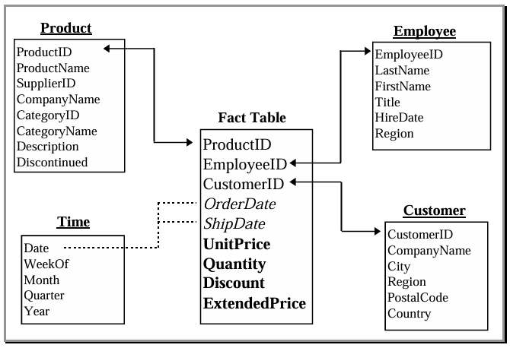
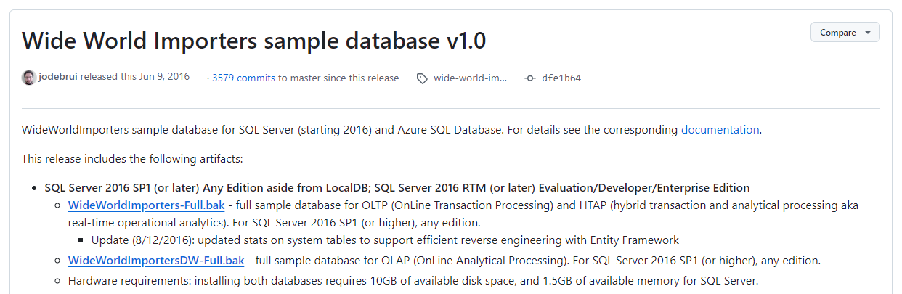
- Download dataset:

- Restore the backup file
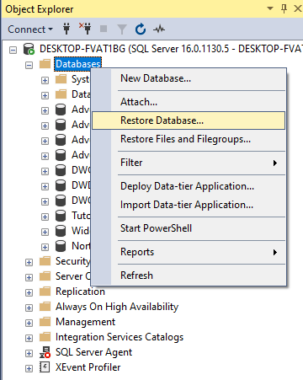

- Now dataset is loaded in WideWorldImportersDW:
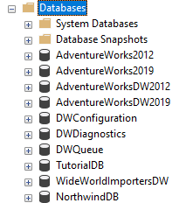
- Allow access to user
Implementing designed warehouse in Analysis Service:
- Create a project in Visual Studio based on Analysis service template
- Create data source to the recently restored database
- Create Data Source View (DSV) against data source and choose tables which are required for analysis (already decided in design phase), Connect fact table with Employee and Date table using their primary keys.
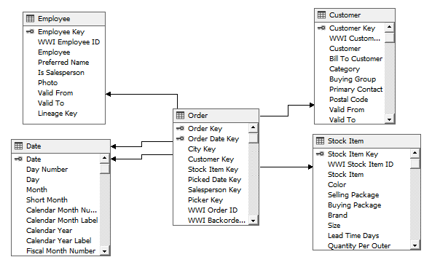

- Create dimensions and verify each exploring via browser and deploy incrementally to see the problems:
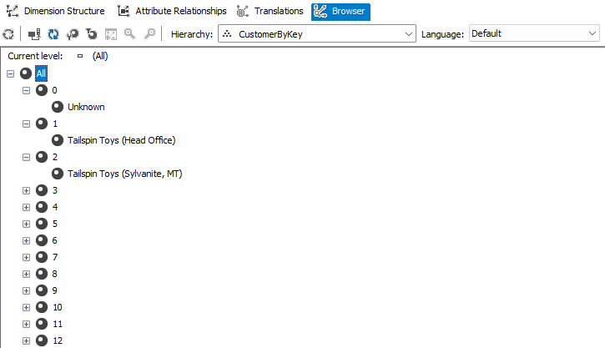

- Now create a cube using existing tables, choose suggested measures group tables, choose measure required for analysis like order count, quantity, unit price. Choose created dimensions and name for the cube.
- Deploy and process the cube.
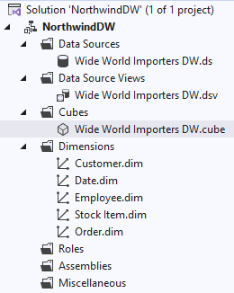
- Go to browser of created cube and click Analyse in Excel.
- Now analyse the data with different perspectives using pivot table in reporting tool:
